**Report for Cryptocurrency Trading Strategy**

1. **Executive Summary**

Asset: Bitcoin

Exchange: Binance

Strategy: long buy bitcoin when exchange balance is at low level, vice versa.

Compute ***40-day*** simple moving average (*SMA*) and standard deviation (*std*) of Binance exchange balance of Bitcoin.

Set up middle band (*SMA*), lower band (*SMA –* ***1.2*** *\* std*) and upper band (*SMA +* ***1.2*** *\* std*).

1. LONG BUY Bitcoin when exchange balance in Binance crosses the lower band.
2. SHORT SELL Bitcoin when exchange balance in Binance crosses the upper band.
3. Exit the market when the exchange balance crosses the middle band.
4. Otherwise, no trade.

The above strategy can potentially generate $110233.68 revenue in 6.5 years with initial capital about $10000 (note that the price of bitcoin has grown from $10000 to $60000 during this period).

Throughout 172 transactions (long 87:85 short), Sharpe ratio is 1.8935 while maximum drawdown is -109.12853214393448% of the accumulated return incurred.

1. **Background**

**The exchange balance**, which refers to the total amount of cryptocurrencies held on cryptocurrency exchanges, can provide insights into investors' activity and sentiment.

**Increased inflows** of cryptocurrencies to exchanges suggest that investors are potentially preparing to sell or trade their holdings.

**Increased outflows** from exchanges may indicate that investors are withdrawing their cryptocurrencies for long-term holding or for use in other applications.

Graph 1: Binance BTC Exchange Balance v.s. BTC Price since 2018:

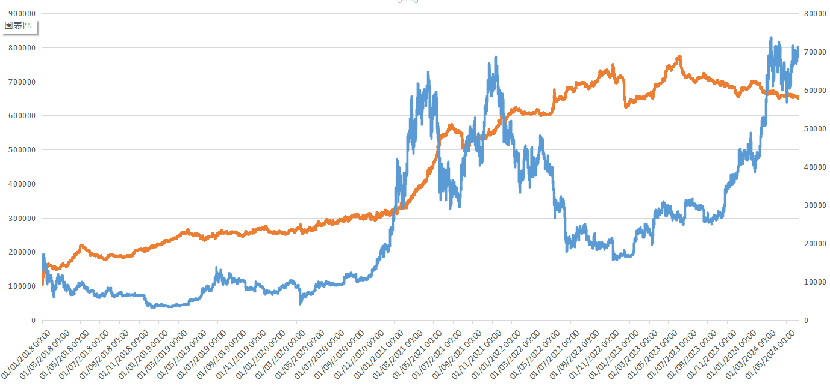

The exchange balance is a valuable metric that can be leveraged to inform profitable trading strategies. The key consideration is the methodology.

In this report, Bollinger band (Z score) will be demonstrated.

1. **Back Test**
   1. **Data Preparation**

Data is fetched from Glassnode API.

Period: 01/01/2018 – 14/06/2024 (338010 data points)

Frequency: 10 minutes

Sample size: 338010 * 2/3 = 225340

Test size: 338010 * 1/3 = 112670

Table 1: Preprocessed data (part)

* 1. **Strategy**

Bollinger Bands consist of three lines: a simple moving average (the middle band) and *n* standard deviation bands above and below the moving average (the upper and lower bands).

Bollinger Bands adjust their width based on market volatility, with wider bands indicating higher volatility and narrower bands indicating lower volatility.

Strategy:

1. LONG BUY cryptocurrency when exchange balance in Binance crosses the lower band.
2. SHORT SELL cryptocurrency when exchange balance in Binance crosses the upper band.
3. Exit the market when the exchange balance crosses the middle band.
4. Otherwise, no trade.

Parameters:

1. *n*, the number of standard deviations above and below the moving average for the construction of the upper and lower bands.
2. *d*, the number of days involved in computing moving average and moving standard deviation

Variations:

1. Exit conditions (crosses the middle band or outer bands?)
2. Simple moving average v.s. Exponential moving average
3. Split bet
4. Multiple coins trading
   1. **Simulation**

This part is for parameter tuning and strategy adjustments. The main visualization tool is heatmap. The vertical axis is the z-score threshold. The horizontal axis is the number of days for computing moving average and standard deviation.

* + 1. Exit when exchange balance crosses middle band

|  |  |
| --- | --- |
| **NO DELAY, Exit when exchange balance crosses middle band** | |
| **Test_set 1**  z-score threshold: 1.2  number of days for computing moving average and std: 30  sharpe_ratio: 1.83989650296294  accumulated return: 17926.231670927664  number of transaction: 80  long-short ratio: 39:41  max_drawdown: -51.478545666531794% |  |
| **Test_set 2**  z-score threshold: 1.8  number of days for computing moving average and std: 5  sharpe_ratio: 1.7517021545782194  accumulated return: 48241.426405537204  number of transaction: 382  long-short ratio: 192:190  max_drawdown: -53.68989345142513% |  |
| **Test_set 3**  z-score threshold: 0.6  number of days for computing moving average and std: 5  sharpe_ratio: 1.8727553641196604  accumulated return: 57524.92900688368  number of transaction: 416  long-short ratio: 206:210  max_drawdown: -36.57448297174779% |  |
| **Whole set**  **z-score threshold: 1.0**  **number of days for computing moving average and std: 20**  **sharpe_ratio: 1.9065811895774252**  **accumulated return: 111599.44654441833**  **number of transaction: 382**  **long-short ratio: 192:190**  **max_drawdown: -75.2117197502773%** |  |
| **DELAY (20-minute), Exit when exchange balance crosses middle band** | |
| **Test_set 1**  z-score threshold: 1.0  number of days for computing moving average and std: 30  sharpe_ratio: 1.6971475822685398  accumulated return: 53662.0135945  number of transaction: 25  long-short ratio: 12:13  max_drawdown: -50.18544972423782% |  |

Heatmap for Sharpe Ratio with respect to *n* and *d*.

Time delay does not cause significant impact on strategy performance.

* + 1. Exit when crosses outer band

|  |  |
| --- | --- |
| **Test_set 1**  z-score threshold: 0.4  number of days for computing moving average and std: 50  sharpe_ratio: 1.6917065384799292  accumulated return: 53198.69527120998  number of transaction: 69  long-short ratio: 34:35  max_drawdown: -53.58275175288318% |  |
| **Test_set 2**  z-score threshold: 0  number of days for computing moving average and std: 15  sharpe_ratio: 1.5222478897399792  accumulated return: 31463.61070424312  number of transaction: 590  long-short ratio: 295:295  max_drawdown: -75.2468883577433% |  |

By comparing the test set 0 results between two exit conditions, **exit when exchange balance crosses middle band** give a better and more reliable performance based on the graph pattern.

Basic enter and exit conditions are confirmed:

* + 1. SMA v.s. EMA

The back tests above use SMA. Now, use EMA instead.

|  |  |
| --- | --- |
| **Test Set 1**  z-score threshold: 1.0  number of days for computing moving average and std: 25  sharpe_ratio: 1.8603647277663744  accumulated return: 21167.88971091537  number of transaction: 100  long-short ratio: 49:51  max_drawdown: -52.82792267204155% |  |
| **Test Set 2**  z-score threshold: 2.0  number of days for computing moving average and std: 5  sharpe_ratio: 1.7936827158857624  accumulated return: 52935.18145892034  number of transaction: 340  long-short ratio: 172:168  max_drawdown: -41.90856576975425% |  |

The results are similar. Switching from SMA to EMA does not significantly improve the performance of the strategy.

* + 1. A screen shot of a chart

       Description automatically generatedSplit bet

Use the result in 3.3.1 test set 3 (no delay). z-score threshold = 1.2, number of days = 50 Test z-score threshold for second trade: [1.2, 1.4, 1.6, 1.8, 2.0]

Splitting bet does not show significant improvement on strategy performance.

**Parameters confirmed: Exchange balance z-score threshold: 1.2 Number of days for computing moving average and standard deviation: 40**

* + 1. Testing the strategy on other coins

Ethereum

Data since 06/07/2023.

z-score threshold: 1.2

number of days for computing moving average and std: 40

sharpe_ratio: 1.8076166708631356

accumulated return: 2980.036422571801

number of transaction: 23

long-short ratio: 11:12

max_drawdown: -36.68190530776789% *****************************************************************

Data from 04/08/2022 to 05/07/2023.

z-score threshold: 1.2

number of days for computing moving average and std: 40

sharpe_ratio: 1.3696092400173554

accumulated return: 553.8936758722003

number of transaction: 15

long-short ratio: 8:7

max_drawdown: -41.1271731579846% *****************************************************************

Data from 03/09/2021 to 03/08/2022

z-score threshold: 1.2

number of days for computing moving average and std: 40

sharpe_ratio: -1.5682827616792456

accumulated return: -1770.257236751196

number of transaction: 21

long-short ratio: 10:11

max_drawdown: -111.42685209287673%

*****************************************************************

Data from 02/10/2021 to 02/09/2021

z-score threshold: 1.2

number of days for computing moving average and std: 40

sharpe_ratio: -1.5653402574404953

accumulated return: -1939.0357067676955

number of transaction: 16

long-short ratio: 8:8

max_drawdown: -184.91642458250078%

The strategy has worked for ETH only during the past two years. It is hard to conclude whether the strategy works also for other coins.

1. **Conclusion**

Asset: Bitcoin

Exchange: Binance

Strategy:

Compute ***40-day*** simple moving average (*SMA*) and standard deviation (*std*) of Binance exchange balance of Bitcoin.

Set up middle band (*SMA*), lower band (*SMA –* ***1.2*** *\* std*) and upper band (*SMA +* ***1.2*** *\* std*).

1. LONG BUY Bitcoin when exchange balance in Binance crosses the lower band.
2. SHORT SELL Bitcoin when exchange balance in Binance crosses the upper band.
3. Exit the market when the exchange balance crosses the middle band.
4. Otherwise, no trade.

Strategy back test result for the whole dataset:

sharpe_ratio: 1.8935

accumulated return: 110233.68

number of transactions: 172

long-short ratio: 87:85

maximum drawdown: -109.12853214393448% (accumulated return approach)

Bollinger Band Demonstration

Cumulative Earnings

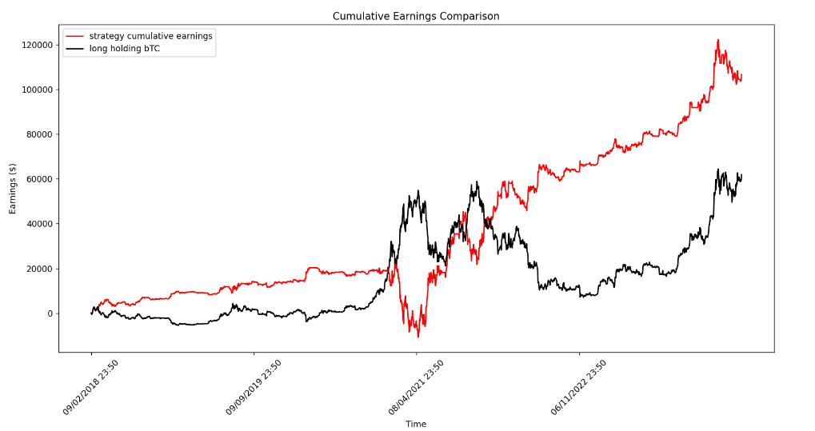

1. Workplace

<https://github.com/cheungkimhang/cryptocurrency-machine-learning.git>